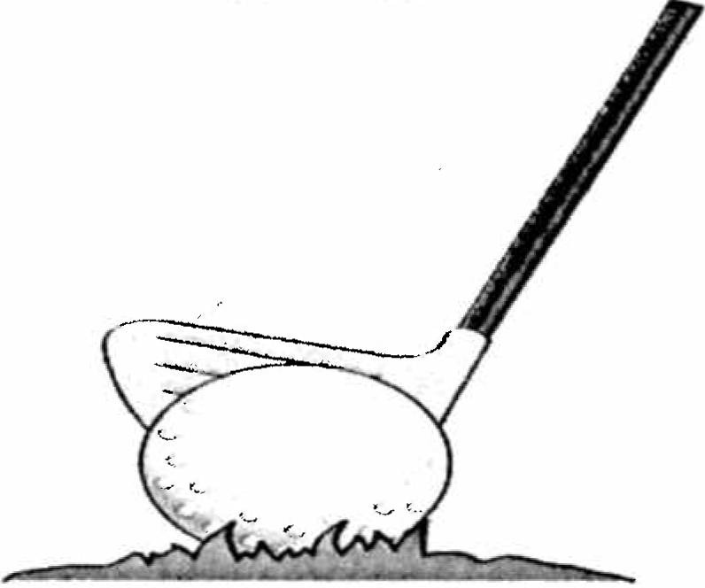
McKNIGHT VILLAGE CIVIC ASSOCIATION 2018 GOLF OUTING SATURDAY Sept. 22nd
STRAWBERRY RIDGE GOLF COURSE

Four Man Scramble Format

Shotgun Start at 9:00 am

Long Drive
$80.00 Per Person

Long Putt Price Includes: Hot Dog and pop at the course, Closest to Pin (3) Steak Dinner at McKnight Village Rec. – Beer! Winning 4 Golfers All Tickets Sold in Advance Only!
Proceeds Benefit The Rec. Playground

Golfer Names
1)  Send Checks To:  McKnight Village  Civic Association  P.O. Box 15372  Pittsburgh, PA 15237 |  | $
2) |  | $
3) |  | $
4) |  | $
 | Total | $

